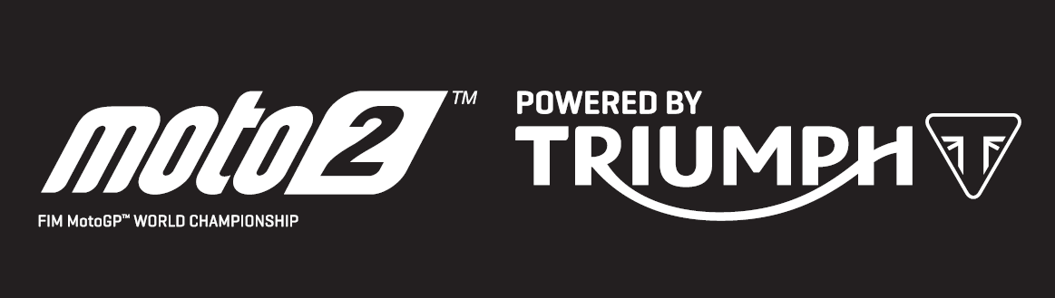

PRESS RELEASE

A clean sweep of records powered by Triumph in Mugello, including the first ever 300km/h top speed in Moto2™

It was Alex Marquez who secured his second 2019 victory in a row at the Italian Grand Prix in dominant style. It is the first time the Spaniard has scored back-to-back victories in five years, since he won the Moto3™ World Championship in 2014. But that was only half the story, as once again Triumph 765cc triple engines powered the Moto2™ field to a clean sweep of new records.

The first stand out moment of the weekend was Sky Racing Team VR46’s Nicolo Bulega, who in free practice 2 became the first rider to achieve 300km/h (187 mph) on a Moto2™ machine. From the 765cc triple, that’s more than 100km/h per cylinder, and the fastest the category has ever seen.

Then in qualifying, as the ground temperature rose to 45 degrees Celsius, it was Marcel Schrotter’s turn to shine as the Dynavolt Intact GP rider set an all-time lap record. Beating the previous lap record by almost one second, the top six riders in qualifying were all faster than the existing outright record which dated back to 2015.

Then in the race, a new lap record was set by Marquez on his way to a victory which boosts him to second in the championship, just two points behind leader Lorenzo Baldassarri. The Flexbox HP40 rider could only manage 15th position in qualifying and was on the back foot coming into the race, but a blistering start saw him gain five places on the opening lap and his relentless pace saw him on the tail of the podium battle with three laps remaining to save his title lead.

After six races, the top three in the title chase are separated by just four points, so as well as Moto2™ having never been so fast, it’s also never been so close.

Steve Sargent, Triumph’s Chief Product Officer, said: “Achieving over 300k/h is a real milestone and something we’re very proud of, really demonstrating the power of our 765cc triple. It’s also wonderful to see riders with the front wheel in the air still at over 250km/h! Mugello has been another very good weekend for the performance of our engine as it continues to redefine the speed and the performance of the Moto2 category, and continues to break records almost every weekend.”

The Triumph Moto2™ 765cc race engine is a development of the class-leading Street Triple RS 765cc road motorcycle and produces more than 140PS and the same visceral soundtrack.

Next up in the June trio of races is the Grand Prix of Catalunya, where the sport celebrates 70 years of Grand Prix racing and Triumph will power Moto2™ around the Barcelona circuit on 16th June.

#PoweredByTriumph #TriumphOfficial

ENDS

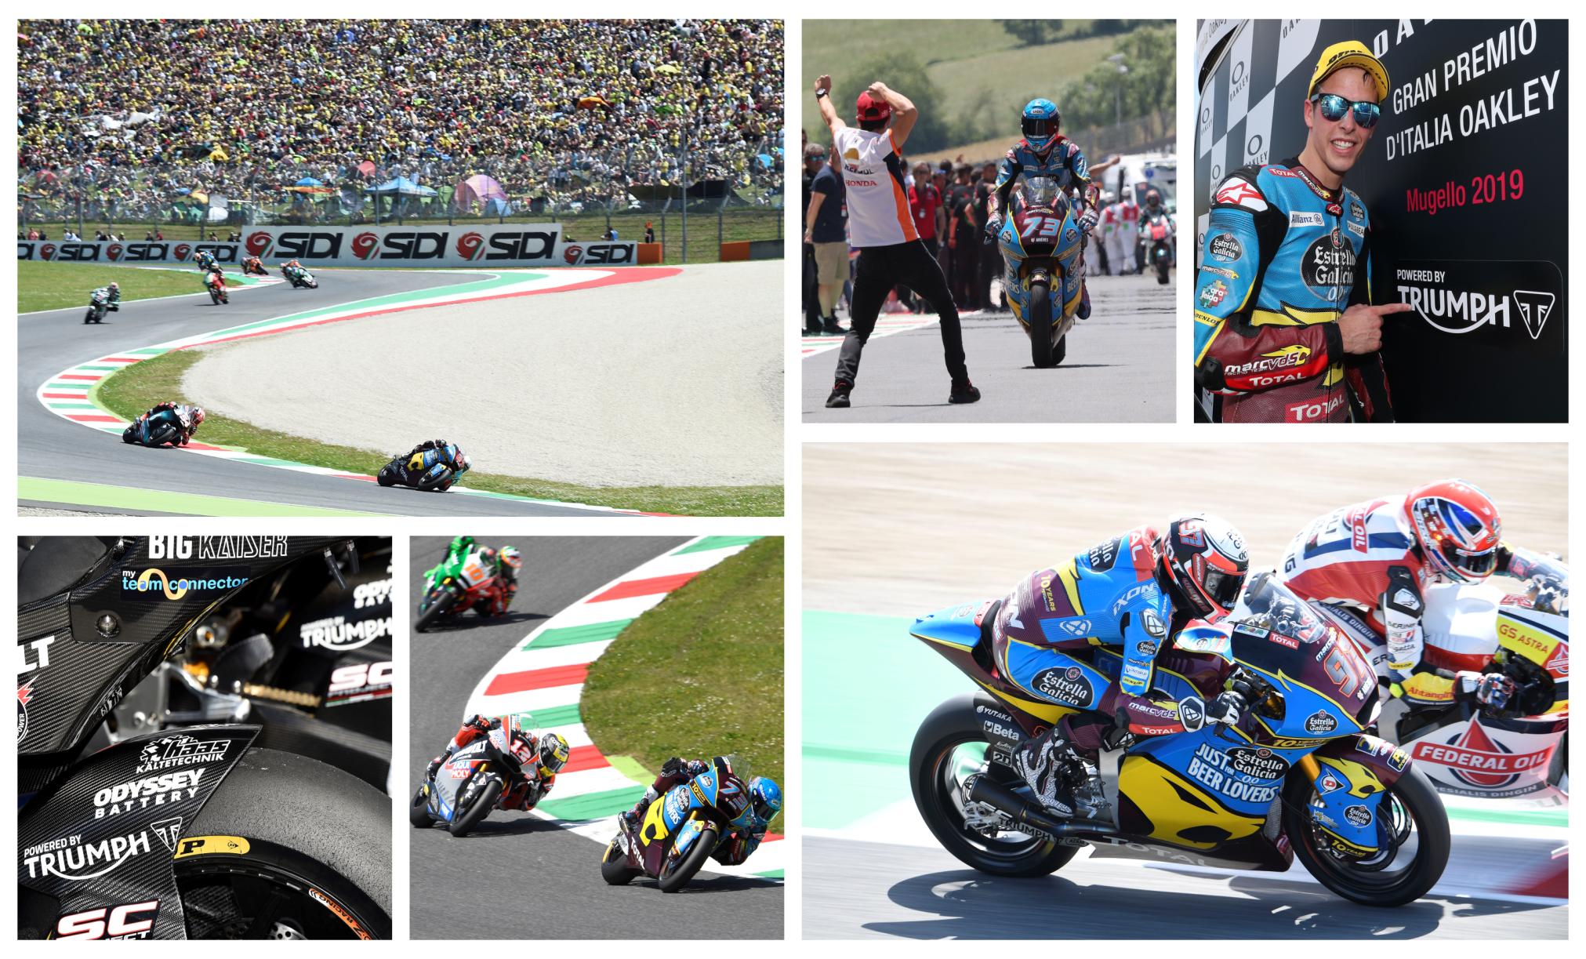
Notes to Editors
About Triumph
- The Triumph Moto2™ 765cc race engine is a development of the class-leading Street Triple RS 765cc road motorcycle and producing more than 140ps and the same visceral soundtrack.
- First established in 1902, Triumph Motorcycles celebrated 110 years of motorcycle manufacture in 2012. For more than two decades, Triumph Motorcycles has been based in Hinckley, Leicestershire, and has produced iconic bikes that perfectly blend authentic design, character, charisma and performance.

- Building around 65,000 bikes per year, Triumph is the largest British motorcycle manufacturer and has around 620 dealers across the world.

- This focus, innovation and engineering passion has today created a broad range of bikes suited to all motorcycle riders, including the iconic new Scrambler 1200, epic Speed Triple, the game changing all new Street Triple 765, the class defining Tiger 800, transcontinental Tiger 1200, iconic Triumph Bonneville family including the stunning Speed Twin, Bonneville Bobber, legendary Thruxton, accessible Street Twin, Street Scramble and iconic Bonneville T120 and T100, plus an exciting and accessible A2 range of Triumph motorcycles

- Triumph currently employs around 2,000 personnel worldwide and has subsidiary operations in the UK, North America, France, Germany, Spain, Italy, Japan, Sweden (Scandinavia), Benelux, Brazil, India and Thailand as well as a network of independent distributors. Triumph has manufacturing facilities in Hinckley, Leicestershire, and Thailand plus CKD facilities in Brazil and India.

- The Triumph Bonneville, famously named to celebrate Triumph’s 1956 land speed record on the Bonneville Salt Fla[ts in Utah, USA, was the original British superbike and a race-winner straight out of the crate. Chosen by famous motorcyclists of the past for its legendary handling, style, and character. It’s that handling, character and style, married to modern rider-focused technology that makes the new Bonneville family THE authentic modern classic choice today.

- Triumph has a glorious racing history, competing in and winning races in almost every class and field of motorcycle sporting achievement. From winning the second ever Isle of Man TT in 1908, through to 1960s road and track domination in Europe and America, right up to contemporary racing achievements with the 675cc Triumph triple powered 2014 Daytona 200 win, the 2014 Isle of Man Supersports TT, 2014 and 2015 British Supersports titles and World SuperSport racing. And now with the new generation of 765cc triple engine powering the 2019 Moto2™ championship, Triumph’s racing legend continues.

